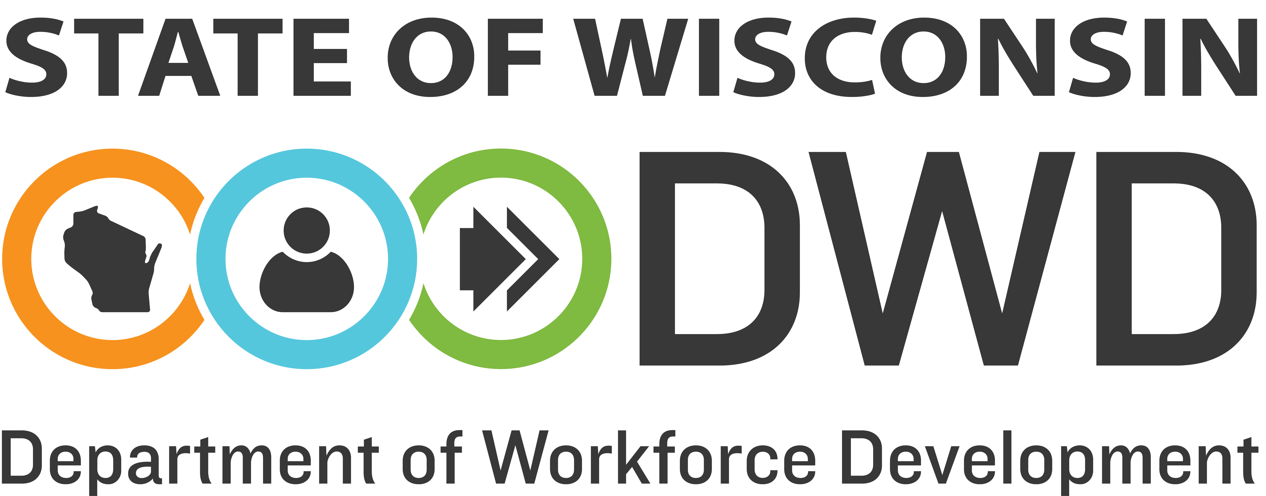
Department of Workforce Development
WIOA Event Hosting Approval Request Form

Please fill out this form in full and email it to the Local Program Liaison.

Date of Request: Click or tap here to enter text.

Requested By (Name, Title, Organization): Click or tap here to enter text.

Purpose of (attach supporting documents such as an agenda): Click or tap here to enter text.
Conference Date(s): Click or tap here to enter text.

Conference Location: Click or tap here to enter text.

Itemized Cost of Conference: Click or tap here to enter text.

Funding Sources to Be Charged with Percent of Cost: Click or tap here to enter text.
WIOA
How Does the Conference Meet the Reasonable and Necessary Standards of 2 CFR § 200.432 and § 200.403?
Click or tap here to enter text.

DWD-DET Office Use Only:

Approved
Denied; Provide rationale for denial:

Local Program Liaison Signature: ______________________________________Date: ___________________

DWD is an equal opportunity employer and service provider. If you have a disability and need assistance with this information, please dial 7-1-1 for Wisconsin Relay Service. Please contact the Division of Employment and Training at 888-258-9966 and press 6 to request information in an alternate format, including translated to another language.

