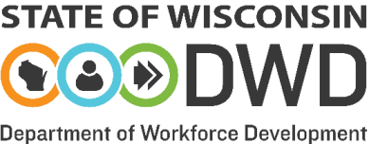

Notice of Local One-Stop Delivery System Changes

The purpose of this form is to notify DWD-DET of the following changes to certified American Job Centers (AJCs) in the Workforce Development Area (WDA):
- comprehensive to affiliate status changes,
- affiliate to comprehensive status changes, and
- closures.

In the event of these changes, the Workforce Development Board (WDB) must provide a minimum seven-day public notice or longer in accordance with established local policies and procedures.
Please contact your Local Program Liaison if there are American Job Centers in the WDA that have not been certified.

As a representative of Choose an item. and on behalf of the counties within the WDA, I hereby notify the state of changes to the certified American Job Centers in the WDA's One-Stop Delivery System.

We assure DWD-DET that Choose an item. maintains at least one certified comprehensive American Job Center, as required by 20 CFR 678.300(c).

This form must be completed and submitted to the WIOA Governance & EO Specialist within 30 days of the change.
STATUS CHANGES: The following American Job Centers have changed their status.
Name of Center | Address | From | To | Effective Date
 |  | Choose an item. | Choose an item.
 |  | Choose an item. | Choose an item.
 |  | Choose an item. | Choose an item.

CLOSURES: The following American Job Centers have permanently closed since the WDA's most recent American Job Center certification.
Name of Center | Address | Effective Date

Printed Name of Chief Elected Official Signature of Chief Elected Official Date

Printed Name of Workforce Development Signature of WDB Director Date

WIOA Title I-A & I -B Policy and Procedure Manual Chapter 2.8

