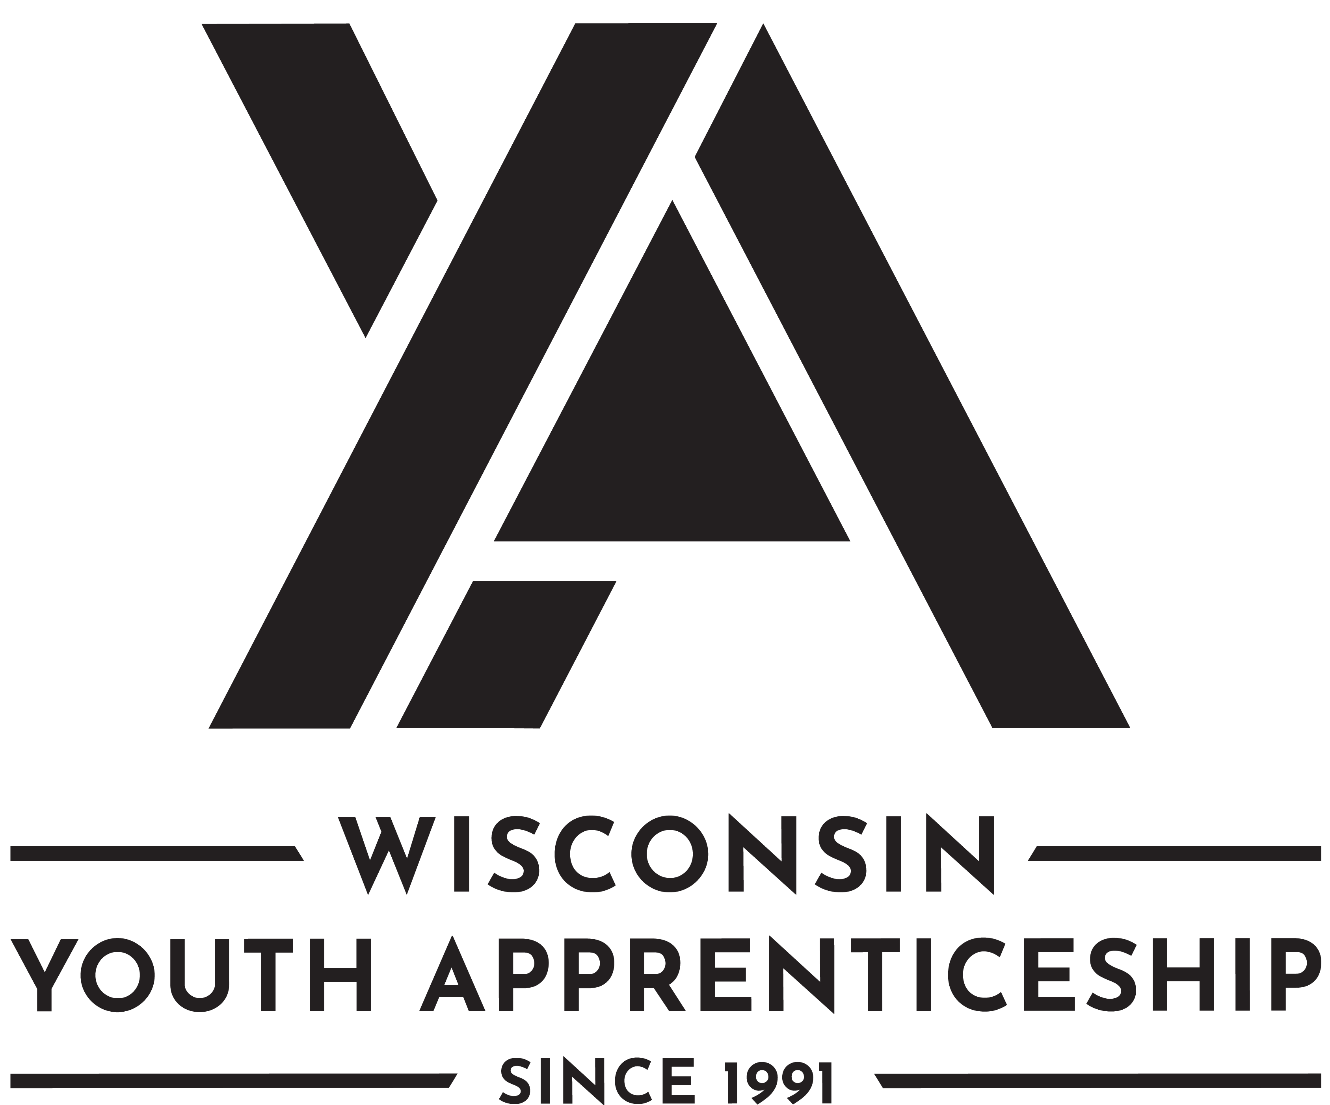 | Architecture and Construction Pathways  Youth Apprenticeship  Related Instruction Guide

Recommendations
These recommendations are intended to be used by the YA Consortiums to determine appropriate related technical instruction for the youth apprenticeship programs in the Architecture and Construction Pathways cluster. These recommendations are not all-inclusive.

Related Instruction Credits
The minimum number of related instruction credits for youth apprentices per year is indicated below. Youth apprentices may take more related instruction courses than the minimum required. No matter the options offered for the related instruction, youth apprenticeship students must receive high school credit toward graduation.
Options for related instruction include the following.
Course Options | Minimum Number of Credits
High School Course | 1 high school credit per year
College Course | 3 college credits per year
Other options: employer provided training, online learning, independent study, etc. | 1 high school credit (options may be combined in various ways but must be equal to one high school credit—the student must receive high school credit toward graduation for this work)
Students must complete one of the options above.

Related Instruction options
Related instruction must be provided to all youth apprentices to support the attainment of knowledge necessary to master the competencies. Courses selected for related instruction should be aligned to the competencies identified in the program On-the-Job Learning (OJL) Performance Standards Guide.
Related courses can be drawn from a variety of options:
Type | Description
Registered Apprenticeship Bridge Courses | Youth apprentices may take courses that are part of the registered apprenticeship at local technical colleges or at other technical colleges online. These courses provide excellent options for students because they provide a pathway for the student to seamlessly bridge into the registered apprenticeship having completed some of the required coursework.

Type | Description
College Transcripted/Dual Credit Courses | Transcripted credit courses (also referred to as dual credit) provide an opportunity for the student to earn college credit directly from the college. Usually offered through the technical college, these courses may be taught by a technical college instructor or a high school instructor who holds an appropriate credential. Transcripted credit courses are good options because they allow students to earn credit toward a degree at the technical college or sometimes toward related instruction in a registered apprenticeship.
High School Courses | High school courses that relate to the apprenticeship job competencies can be used for related instruction. Sometimes these courses can be articulated with the local technical college for advance standing. If the student goes on to take courses at the technical college, advance standing may be awarded for the course based on an articulation agreement between the high school and the college.
Other Options | Other options to help students learn related instruction content include:  - Employer provided training  - Online courses provided by professional organizations  - Independent study courses offered at the local high school  These options can be combined in various ways provided they are related to the competencies in the On-the-Job Learning (OJL) Performance Standards Guide and meet the minimum number of hours required for one high school credit.

Checklist for Course Selection
When choosing the courses for a youth apprenticeship using the competencies in the On-the-Job Learning Performance Standards (OJL) Guide, consider these questions or refer to the decision flowchart.
- Does the course bridge to a registered apprenticeship?
- Does the course apply to a related college program?
- Does the course qualify for dual credit?
- Does the course qualify as a Perkins Pathway CTE course?
- Is the course required for an occupation certification?
If YES to any above:
- Is the course accessible to the student?
NOTE: Course accessibility is determined by district or high school availability, transportation, course supply accessibility, course offering timeline, and distance or virtual learning resources required.
If NO to any above, contact the DWD YA Staff through the YA mailbox (ya@dwd.wisconsin.gov) to discuss options.
If YES to all the above:
Register the student for the class.

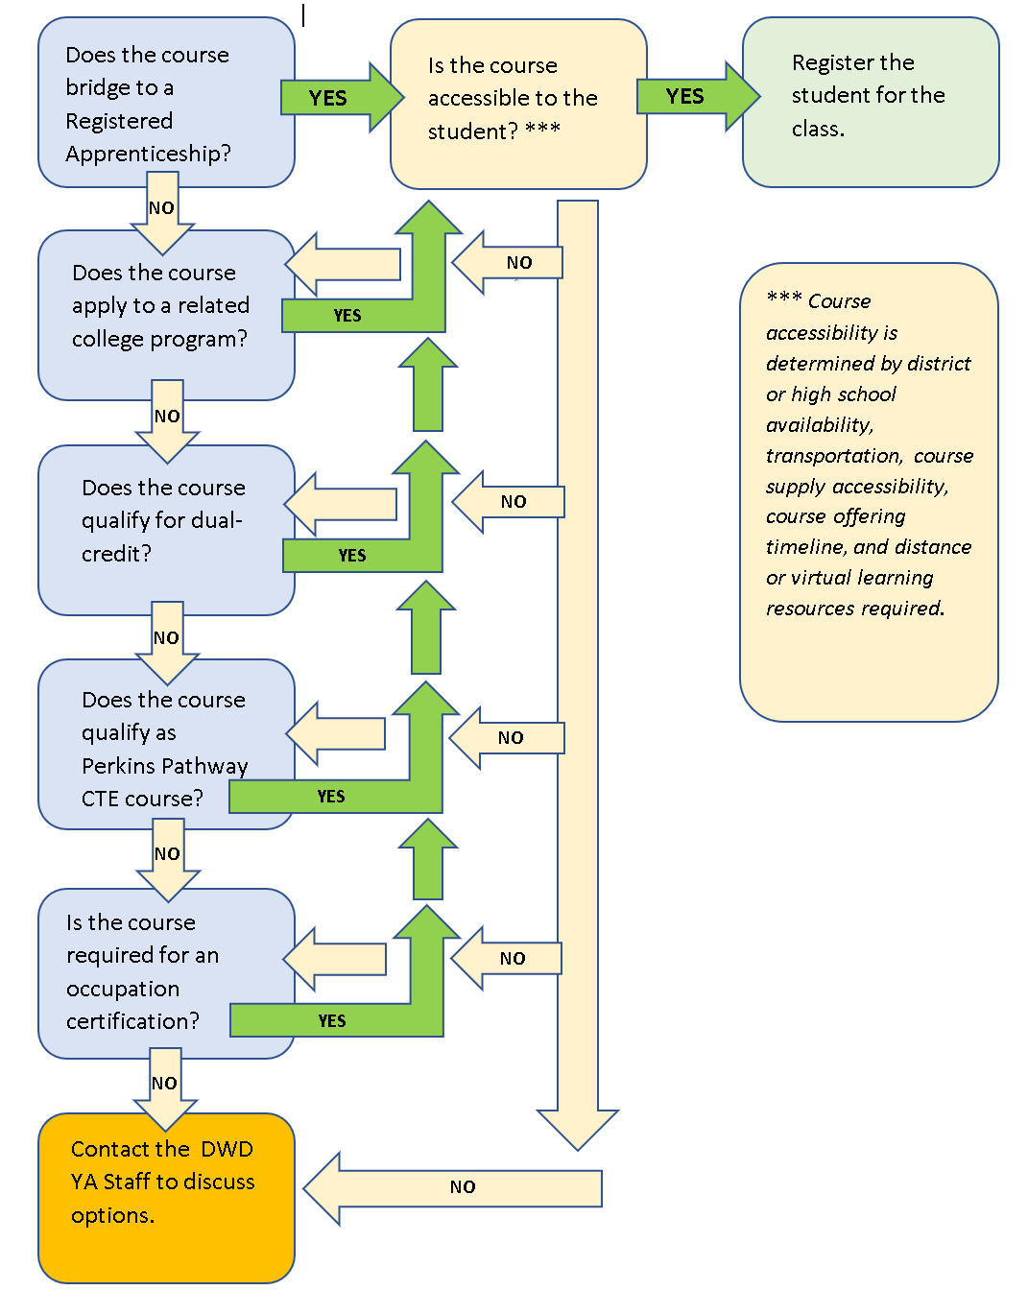

Opportunities for Registered Apprenticeship Bridge
The following programs can bridge into a registered apprenticeship.
Youth Apprenticeship | Registered Apprenticeship
Carpentry Fundamentals | Carpenter
Electrical Fundamentals | Residential Wirer  Construction Electrician
Masonry/Concrete Fundamentals | Cement Mason/Concrete Finisher
Mechanical/HVAC Fundamentals | Sheet Metal Worker – Commercial  Sheet Metal Worker - Residential
Plumbing/Sprinkler Fitting Fundamentals | Sprinklerfitter
Heavy Equipment Operator and Operating Engineer | Heavy Equipment Operator and Operating Engineer
Utilities Field Technician | Metering Technician  Substation Electrician
Gas Distribution Technician | Metering Technician  Substation Electrician
Note: Youth apprentices interested in bridging to the Construction registered apprenticeship may be eligible for some registered apprenticeship related instruction. YAs should contact their local WTCS college for specific opportunities.

Architectural Drafting Pathway

Suggested Related Instruction Courses for Architectural Drafting Pathways
The following courses are suggested as options for related instruction because they are aligned to the apprenticeship competencies in the On-the-Job Learning (OJL)Performance Standards Guide. These recommendations are not all-inclusive.

Recommendations College Courses (titles are representative)
Course | Credits (College) | Architectural Drafting | Architectural Planning
Blueprint Reading | 1-3 | X | X
Intro to Architecture or Architectural Design | 3 | X | X
Construction Materials | 3 | X | X
LEED/Sustainability | 1-3 | X | X
Interior Design | 3 | X | X
CAD/CAD 2-D/AutoCAD | 1-3 | X | X
SolidWorks | 1-3 | X | X
Revit | 1-3 | X | X
College Mathematics | 3 | X | X
Intro to Building Construction | 3 | X | X
Construction Fundamentals | 2 | X | X

Construction Pathways

Suggested Related Instruction Courses for CONSTRUCTION PATHWAYS
The following courses are suggested as options for related instruction because they are aligned to the apprenticeship competencies in the On-the-Job Learning (OJL) Performance Standards Guide. These recommendations are not all-inclusive.
Course | Credits (College) | Carpentry | Electrical | Masonry/ Concrete | Mechanical/ HVAC | Plumber/ Sprinkler Fitter
Blueprint Reading | 1-3 | X | X | X | X | X
LEED/Sustainability |  | X | X
Intro to Building Construction | 3 | X | X | X | X | X
Construction Fundamentals | 2 | X | X | X | X | X
Woodworking | 2-3 | X
Shop Safety & Machining | 2 | X | X | X | X | X
Intro to Carpentry | 1-3 | X
Basic Welding | 1-2 | X |  |  | X | X
Residential Wiring | 3 |  | X
AC/DC Theory | 3 |  | X
PLC (Programmable Logic Controller) | 1-3 |  | X |  | X
OSHA 10 | .25 | X | X | X | X | X

Heavy Equipment Operator and Operating Engineer Pathway

Suggested Related Instruction Courses for HEAVEY EQUIPMENT OPERATOR AND Operating Engineer
The following courses are suggested as options for related instruction because they are aligned to the apprenticeship competencies in the On-the-Job Learning Performance Standards Guide. Note that these courses DO NOT bridge directly to the registered apprenticeship. See below for information regarding courses that do bridge. These recommendations are not all-inclusive.
Course | Credits (College) | Heavy Equipment Operator and Operating Engineer
Blueprint Reading | 1-3 | X
Basic Welding | 1-2 | X
CDL Permit Preparation | Not Typically Offered for Credit | X
Maintenance and Light Repair | 1-4 | X
Engine Repair | 2-3 | X
Small Power Equipment | 3 | X
Four Cycle Engines | 3 | X
Math for the Machine Trades | 1-3 | X

Bridged Courses to Registered Apprenticeship

Have Equipment Operator and Operating Engineer Bridge Courses
Youth apprentices interested in bridging to the Heavy Equipment Operator and Operating Engineer registered apprenticeship should consider completing the pre-apprenticeship offered through Destinations Career Academy of Wisconsin. Destinations Career Academy collaborates with the Wisconsin Operating Engineers (IUOE Local 139) to offer these courses. Recognition of apprenticeship college credit is provided through the WTCS.

Title | College Credits | High School Credit | Description
Operating Engineers Career Exploration | No college credit | .5 | Elective Credit. This course is optional for students. It will not result in any technical college credit.
Math for the Trades and Basic Grade | 1.25 | .5 | Math for the Trades is a high school level applied math course to prepare students for success in the registered apprenticeship. No technical college credit will be given for this portion of the course.  This course is paired with the Basic Grade. Basic Grade covers instruction in working with the engineer’s ruler using tenths and hundredths, how to calculate basic quantities, working with elevations, figuring cut and fill to finish grade and sub-grade. Topics also include interpreting and working with grade stakes while learning the basic grade setting and staking process. In the field students will be trained how to use lasers, eye levels, standard rods and lenker rods. Also includes a basic introduction to plan reading.
Intro to Basic Equipment | 1.25 | .5 | Introduces heavy equipment used in the construction industry. Students will also be instructed on basic safety, maintenance, and communication methods that operating engineers may be exposed to.
Intro to Basic Maintenance | 1.25 |  | Introduces basic mobile equipment maintenance. Students will be instructed in maintaining engines, hydraulics, electrical systems, lubricants, and machine undercarriages with an emphasis on the use of the operator manual maintenance sections. Shop and field maintenance safety will be daily topics as well as proper use and identification of hand tools and shop tooling.
CDL Preparation/Skills USA PDP | No college credit | .5 | Helps the student prepare for obtaining the Commercial Driver’s License permit. The commercial learner's permit allows students over 18 to drive a tractor trailer as long as they have a licensed CDL holder in the vehicle.

Utilities Pathway

Suggested Related Instruction Courses for Utilities Pathways
The following courses are suggested as options for related instruction because they are aligned to the apprenticeship competencies in the On-the-Job Learning (OJL) Performance Standards Guide. These recommendations are not all-inclusive.

Recommendations College Courses (titles are representative)
Course | Credits (College) | Utilities Field Technician | Gas Distribution Technician
College Mathematics, Applied Math, Technical Math | 3 | X | X
Workplace Safety | 1
CDL Permit | 1 | X | X
Intro to Welding | 1-3 |  | X
Preventative and Predictive Maintenance | 2 | X | X
Construction Practices | 4 | X
Communication | 3 | X | X
Basic Electricity | 1-4 | X

Bridged Courses to Registered Apprenticeship

Number | Title | Credits | Description
50-413-500 | Introduction to Electric Meter Technician | 2.25 | This course will introduce the prospective Electric Meter Technician Apprentice to the job duties related with this skilled trade. The course will introduce job safety in general terms, what utilities are and how they operate, and a short overview of utility history. The student will discover the unique place that a qualified Meter Technician holds in a utility company and be introduced to overall governing regulations. This course should help a candidate decide if this trade is for them, and for those who have decided upon this apprenticeship, the overall relationship of the trade to the industry.
50-413-531 | Meter Technician - Safety | 2.25 | Learners will learn safe work procedures to include installation, disconnect, and reconnect of metering and its associated equipment. Learners will address safety as it relates to meter sets of various voltage levels including secondary (120 to 480 volts) and primary (4KV to 25KV). The learner will apply the various types of Personal Protective Equipment (PPE) and learn how and when to wear it, proper methods for storage and proper methods for inspection of PPE.
50-413-532 | Math for the Meter Technician | 2.25 | In this course the apprentice will learn the basic math and some of the advanced meter math techniques used in the servicing of Meters. Apprentices will calculate customer loads using various methods, they will determine system efficiency, and they determine if meters are wired in the proper manner by calculating vectors and phase angles.
50-413-533 | Meter Technician Customer Relations and Communications | 2.25 | In this course the apprentice will learn the basic communication and customer service techniques to be an effective Meter Technician.

DWD is an equal opportunity employer and service provider. If you have a disability and need assistance with this information, please dial 7-1-1 for Wisconsin Relay Service. Please contact the Division of Employment and Training at 888-258-9966 and press 6 to request information in an alternate format, including translated to another language.

