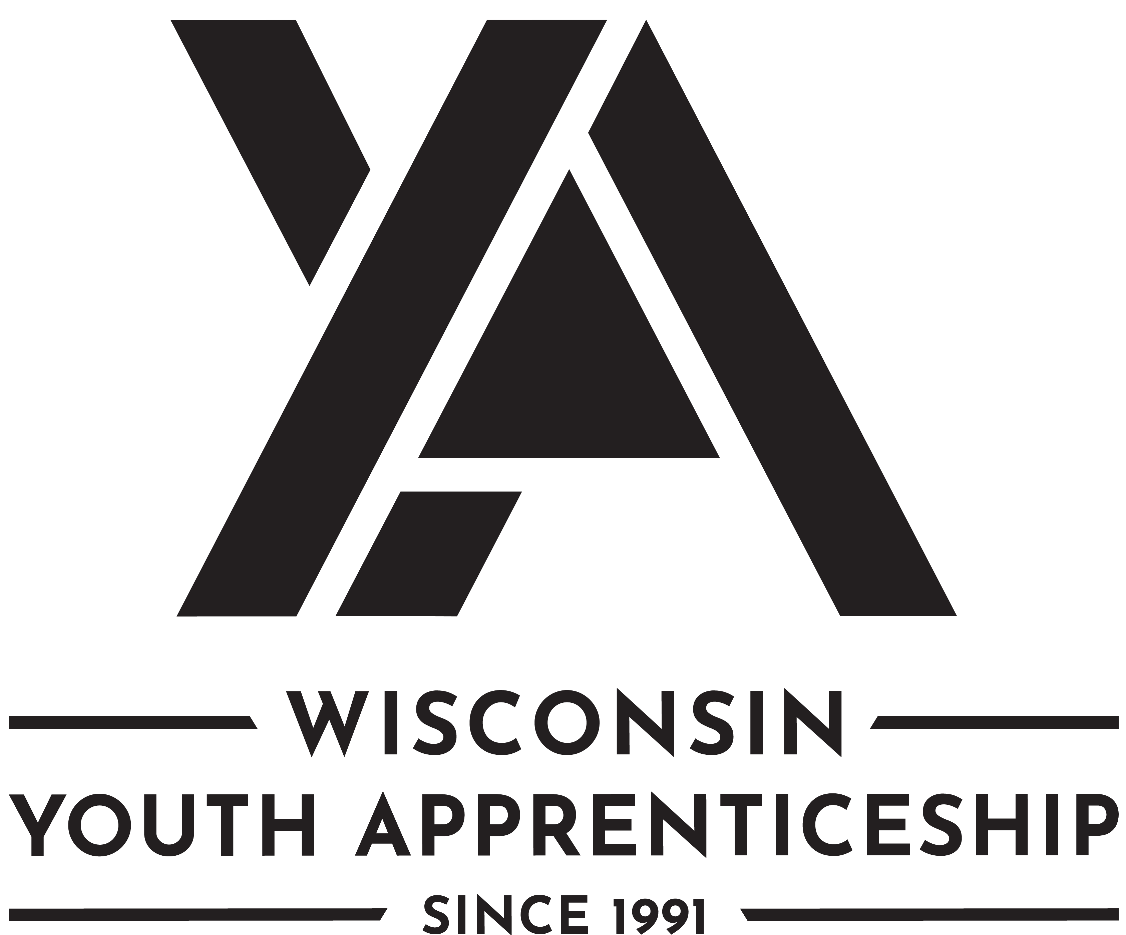 | Agriculture, Food and Natural Resources Pathways  Youth Apprenticeship  Related Instruction Guide

Recommendations
These recommendations are intended to be used by the YA Consortiums to determine appropriate related technical instruction for the youth apprenticeship programs in the Agriculture, Food and Natural Resources (AFNR) Pathways cluster. These recommendations are not all-inclusive.

Related Instruction Credits
The minimum number of related instruction credits for youth apprentices per year is indicated below. Youth apprentices may take more related instruction courses than the minimum required. No matter the options offered for the related instruction, youth apprenticeship students must receive high school credit toward graduation.
Options for related instruction include the following.
Course Options | Minimum Number of Credits
High School Course | 1 high school credit per year
College Course | 3 college credits per year
Other options: employer provided training, online learning, independent study, etc. | 1 high school credit (options may be combined in various ways but must be equal to one high school credit—the student must receive high school credit toward graduation for this work)
Students must complete one of the options above.

Related Instruction options
Related instruction must be provided to all youth apprentices to support the attainment of knowledge necessary to master the competencies. Courses selected for related instruction should be aligned to the competencies identified in the program On-the-Job Learning (OJL) Performance Standards Guide.
Related courses can be drawn from a variety of options:
Type | Description
Registered Apprenticeship Bridge Courses | Youth apprentices may take courses that are part of the registered apprenticeship at local technical colleges or at other technical colleges online. These courses provide excellent options for students because they provide a pathway for the student to seamlessly bridge into the registered apprenticeship having completed some of the required coursework.

Type | Description
College Transcripted/Dual Credit Courses | Transcripted credit courses (also referred to as dual credit) provide an opportunity for the student to earn college credit directly from the college. Usually offered through the technical college, these courses may be taught by a technical college instructor or a high school instructor who holds an appropriate credential. Transcripted credit courses are good options because they allow students to earn credit toward a degree at the technical college or sometimes toward related instruction in a registered apprenticeship.
High School Courses | High school courses that relate to the apprenticeship job competencies can be used for related instruction. Sometimes these courses can be articulated with the local technical college for advance standing. If the student goes on to take courses at the technical college, advance standing may be awarded for the course based on an articulation agreement between the high school and the college.
Other Options | Other options to help students learn related instruction content include:  - Employer provided training  - Online courses provided by professional organizations  - Independent study courses offered at the local high school  These options can be combined in various ways provided they are related to the competencies in the On-the-Job Learning (OJL) Performance Standards Guide and meet the minimum number of hours required for one high school credit.

Checklist for Course Selection
When choosing the courses for a youth apprenticeship using the competencies in the On-the-Job Learning Performance Standards Guide, consider these questions or refer to the decision flowchart.
- Does the course bridge to a Registered Apprenticeship?
- Does the course apply to a related college program?
- Does the course qualify for dual credit?
- Does the course qualify as a Perkins Pathway CTE course?
- Is the course required for an occupation certification?
If YES to any above:
- Is the course accessible to the student?
NOTE: Course accessibility is determined by district or high school availability, transportation, course supply accessibility, course offering timeline, and distance or virtual learning resources required.
If NO to any above, contact the DWD YA Staff through the YA mailbox (ya@dwd.wisconsin.gov) to discuss options.
If YES to all the above:
Register the student for the class.

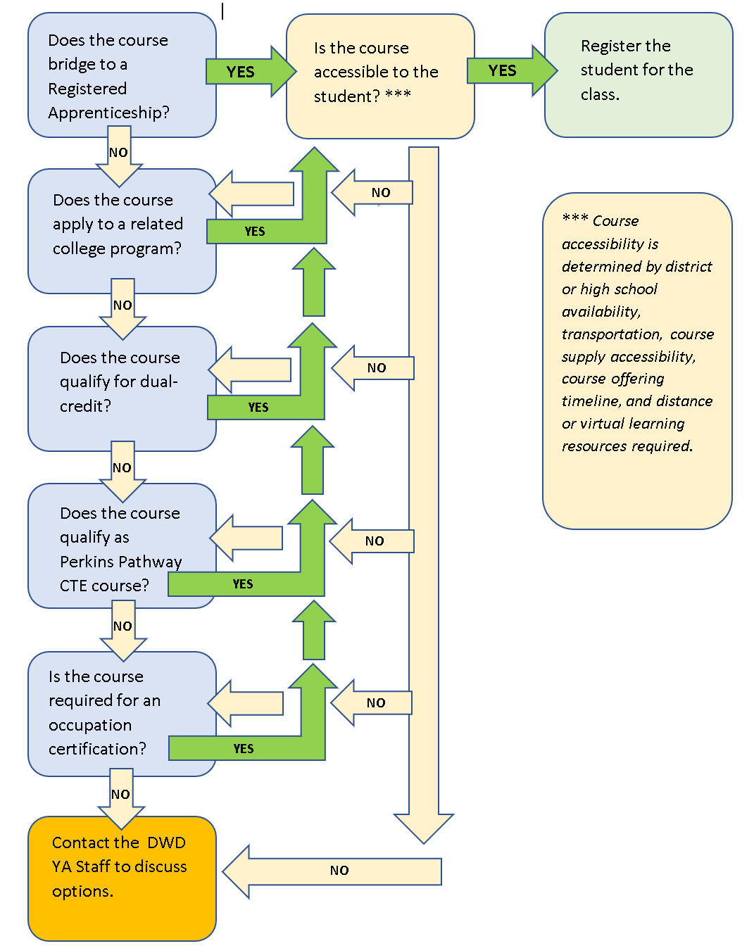

Opportunities for Registered Apprenticeship Bridge
The following programs can bridge into a registered apprenticeship.
Youth Apprenticeship | Registered Apprenticeship
Arborist | Arborist
Plant Fundamentals  Crops | Organic Vegetable Farm Manager
Animal Fundamentals  Animal/Herd  Dairy Grazier | Dairy Grazier
Water Resources | Wastewater Treatment Plant Operator

Agriculture Pathway: Plants

Suggested Related Instruction Courses for Plant Pathways
The following courses are suggested as options for related instruction because they are aligned to the apprenticeship competencies in the On-the-Job Learning (OJL) Performance Standards Guide. These recommendations are not all-inclusive.

Recommendations College Courses (titles are representative)
Course | Credits (College) | Plant Fundamentals | Crops | Landscape | Floral  Greenhouse | Arborist
Intro to Horticulture Plant Science | 3 | X | X | X | X | X
Botany/Plant Biology | 3 | X | X | X | X | X
Crops and Soils | 3 | X | X
Landscape Design | 3 |  |  | X
Landscape Installation | 3 |  |  | X
Greenhouse Crops | 3 | X |  |  | X
Landscape Maintenance | 3 |  |  | X |  | X
Agribusiness Management | 3 |  | X | X | X
College Math | 3-4 |  | X | X |  | X

Bridged Courses to Registered Apprenticeship

Arborist Bridge Courses
Youth apprentices interested in bridging to the Arborist registered apprenticeship should consider completing registered apprenticeship related instruction courses. The following courses bridge directly to the Registered Apprenticeship and may be good candidates. Courses are offered through the WTCS colleges.
Number | Title | Credits | Description
50-001-710 | Arborist Skills 1 | 1 | Apprentices will examine aspects of being an arborist and the trade and occupations related to urban forestry. Course learning outcomes include an orientation to the trade, standards related to the tree care industry, safety and personal protective equipment, electrical hazard awareness; ground support for aerial operations, basic tree biology for first year apprentices, and the basic pruning cuts used by the trade.
50-001-714 | Tree and Shrub Identification 1 for Arborist Apprentices | 1 | Course examines tree and shrub identification using industry accepted standards. Course learning outcomes include anatomy and morphology, tree and shrub identification, and tools used by the trade to identify trees and shrubs. An introduction to insects and diseases will provide foundational knowledge for future courses in related instruction. The first tree & and shrub identification course (1 of 3) will focus on deciduous and coniferous trees from the arborist apprenticeship must-know list.
50-001-718 | Tree Biology & Identification 2 for Arborist Apprentices | 1 | Apprentices will examine tree biology and relate concepts to the work performed by arborists in an urban forestry setting. Course competencies include understanding tree function and structure, categorizing the impact of diseases and pests, examining the CODIT model, and exploring tree risk concepts. Course will examine basic plant health needs, tree sites, and nutrition and soil requirements. The second of 3 tree and shrub identification courses will focus on more coniferous and deciduous trees from the arborist apprenticeship must-know list and explore associated tree and shrub disorders.

Organic Vegetable Farm Manager Bridge Courses
Youth apprentices interested in bridging to the Organic Vegetable Farm Manager registered apprenticeship should consider completing registered apprenticeship related instruction courses. The following courses bridge directly to the Registered Apprenticeship and may be good candidates. Courses are offered through the Wisconsin Technical College System (WTCS) colleges.
Number | Title | Credits | Description
50-080-701 | Organic Farm Systems | 1.5 | Introduces organic and systems approach to vegetable farming. Examines crop rotation plans; weed, pest, and disease plans; soil fertility and conservation plans; and organic certification paperwork. In addition, apprentices examine career pathways in organic vegetable farming and begin a career plan.
50-080-702 | Production Related Farm Management | 1.5 | Provides an overview of production related farm management activities and processes. Emphasis is placed on types of plants, designing a planting plan, growing seedlings, greenhouse management systems, plant health indicators, irrigation methods, weed, pest and disease control methods, harvest handling, and equipment types and maintenance.
50-090-703 | Farm Business Management and Marketing | 1 | Introduces apprentices to the farm business management and marketing processes and tasks needed for Organic Vegetable Farm Managers. Emphasis is placed on developing a farm marketing plan, evaluating a farm business plan, exploring farm recordkeeping systems, and interpreting farm financial information.

Agriculture Pathway: Animals

Suggested Related Instruction Courses for Animal Pathways
The following courses are suggested as options for related instruction because they are aligned to the apprenticeship competencies in the On-the-Job Learning (OJL) Performance Standards Guide. These recommendations are not all-inclusive.

Recommendations College Courses (titles are representative)
Course | Credits (College) | Animal Fundamentals | Animal/ Herd | Small Animal | Dairy Grazier
Intro to Horticulture/Plant Science | 3 |  |  |  | X
Botany/Plant Biology | 3 |  |  |  | X
Animal Science | 3 | X | X | X | X
Dairy Science/Cattle Management | 3 | X | X |  | X
Animal Health/Nutrition | 3 | X | X | X | X
General Welding | 3 | X
Agribusiness Management | 3 |  | X | X | X
College Math | 3-4 |  | X | X

Bridged Courses to Registered Apprenticeship

Dairy Grazier Bridge Courses
Youth apprentices interested in bridging to the Dairy Grazier registered apprenticeship should consider completing registered apprenticeship related instruction courses. The following courses bridge directly to the Registered Apprenticeship and may be good candidates. Courses may be offered through the Wisconsin Technical College System (WTCS) colleges or the Dairy Grazier Apprenticeship (DGA) organization.
NOTE: DGA courses may incur additional tuition costs outside the scope of Youth Apprenticeship.
Number | Title | Credits | Description
50-091-500 | Dairy Nutrition | 1 | Students will learn theory behind farming practices. Topics covered in this course include: roles of digestive nutrients, nutritional requirements at various growth stages, relationship between forage quality and nutrition, ration balancing through calculation of feed, and dry matter intake. Students will learn about various methods of feeding dairy animals, including grazing system principles. Students will also evaluate the use of dairy nutrition feed technologies.
50-091-502 | Dairy Health | 1 | Students will explore the animal environment and adaptation, animal health and behavior as it relates to production and non-production species. Furthermore, it will provide the student with the skills to apply basic veterinary skills, animal behavior, signs of illness, vaccination programs, heard health records, and troubleshoot basic electrical applications.
50-091-503 | Milk Quality | 1 | This course will provide students with a solid background in producing quality milk and utilizing good herd health management practices. Students will be introduced to milking systems and components, milk procedures, sanitation, diseases, udder anatomy, and milk secretion. Students will be exposed to milk quality practices globally.
50-091-102 | Organic Soils, Nutrients, Composting | 1 | Functional soil is the foundation of organic systems. Build robust healthy soil through organic matter, micro-organisms, and nutrient cycling. Explore composting techniques, organic fertilizer sources, soil fertility testing, balancing.
10-091-104 | Introduction to Animal/Dairy Science | 3 | Introduction to the basics of livestock management. It includes management, nutrition, and breeding practices in a Dairy operation through classroom and practical experience. Management of the Dairy herd with concentration on breed identification, reproduction, genetics, selection, calving management, and recordkeeping systems. Furthermore, students will explore potential careers related to the dairy industry.
10-090-102 | Organic Soils, Nutrients, Composting | 3 | Functional soil is the foundation of organic systems. Build robust healthy soil through organic matter, microorganisms, and nutrient cycling. Explore composting techniques, organic fertilizer sources, soil fertility testing, balancing.

Natural Resource Pathway

Suggested Related Instruction Courses
The following courses are suggested as options for related instruction because they are aligned to the apprenticeship competencies in the On-the-Job Learning (OJL) Performance Standards Guide. These recommendations are not all-inclusive.

Recommendations College Courses (titles are representative)
Course | Credits (College) | Water Resources
People, Resources & Sustainability | 3 | X
Introduction to Fisheries, Forestry, Wildlife Resources | 3 | X
Intro to Soil and Water Resources | 3 | X
Environmental Biology | 3 | X
Fluids/Pumps | 3 | X
Plant Biology for Horticulture | 3 | X
College Math | 3-4 | X

Wastewater Treatment Plant Operator Bridge Courses
Youth apprentices interested in bridging to the Wastewater Treatment Plant Operator registered apprenticeship should consider completing registered apprenticeship related instruction courses. The following courses bridge directly to the Registered Apprenticeship and may be good candidates. Courses are offered through Moraine Park Technical College.

Number | Title | Credits | Description
10-527-100 | Introduction to Wastewater Treatment | 3 | Provides an overview of the different processes used in wastewater treatment plants, as well as the collection system and sludge disposal procedures. Covers calculations used to determine plant loadings, detention times and percent removal efficiencies. Environmental regulations, preventive maintenance practices and basic safety precautions are covered.
10-527-103 | Conventional Wastewater Treatment | 3 | Covers the basic biology, chemistry, and operational controls of wastewater treatment processes: pre- and primary treatment of wastewater, activated sludge, trickling filters and RBCs (Rotating Biological Contactors (RBCs). The structure and function of major equipment is explained. Various lab tests and the calculations associated with them are presented.

