Department of Workforce Development
Worker’s Compensation Division
201 E. Washington Ave.
P.O. Box 7901
Madison, WI 53707
Telephone: (608) 266-1340
Fax: (608) 267-0394
https://dwd.wisconsin.gov/wc
e-mail: DWDDWC@dwd.wisconsin.gov

MEDICAL REPORT ON INDUSTRIAL INJURY

*Provision of your Social Security Number (SSN) is voluntary. Failure to provide it may result in an information processing delay.
The Department of Workforce Development (DWD) administers the Worker's Compensation Act, Chapter 102 Wis. Stats. The purpose of this form is to assist with the procurement of information related to or required by Chapter 102. Completion of this form is voluntary and failure to complete said form may result in a delay in the administration of Chapter 102. DWD may use the personally identifiable information (PII) it obtains from you on this form for purposes other than those for which it is being collected.

 | WC Claim Number |  | Employee Name
PATIENT | Employee Social Security Number* |  | Employee Address
 | Injury Date |  | Employer Name |  |  | Insurance Company
HISTORY | History as described by patient

DIAGNOSIS
(Please be as
detailed as
possible)
PERMANENT  DISABILITY | What amputation present? Comparative x-rays taken?  Yes No |  |  |  |  |  | Stump:  hardy or tender
(Describe permanent elements of disability,  such as limitation of | Has permanent disability resulted?  Yes No | Date of Last Exam |  |  | Has healing period ended?  Yes No |  | Patient discharged?  Yes No
motion, pain, weakness, etc., and describe effect  on working ability.) | Description of permanent disability (Record finger motion losses on reverse.)
 | Was surgery performed as a result of accident? Yes No If Yes, state type of surgery:
 | If healing has not ended, what is minimum permanent disability expected?
PRIOR  DISABILITY | What previous disability?
PROGNOSIS | Prognosis:
Date injured was or will be able to return to a limited type of work:
State any limitations:
 | Date injured was or will be able to return to full-time work subject only to permanent limitations:
 | What further treatment should be given?
Additional comments, if any:
Date | City |  |  | Physician or Chiropractor Signature (in own writing)
 | Phone Number  ( ) - |  |  | Typed or Printed Name

WKC-16-E (R. 09/2024)

Employee Name | Employee Social Security Number

Instructions for finger injuries
Please use statutory terms in referring to fingers, such as thumbs, index, middle, ring, and little fingers, and distal, middle, and proximal joints. Where there is limitation of motion, list separately the normal range of motion in degrees, the “degrees” loss of flexion, and the “degrees” loss of extension for each joint of each finger. The Worker’s Compensation Division will evaluate the loss of use due to loss of motion of the fingers.

Where there are other elements of disability of the fingers, such as deformity, weakness, pain, or lack of endurance, give your opinion on the percentage loss of use as compared to amputation for such elements of disability and specify the joint at which such loss is estimated.
Digit | Joint | Angle  Ext/Flex | Normal  Range of  Motion | Degrees  Loss  Extension | Degrees  Loss  Flexion | Estimate % loss of use for additional factors at joint involved and reason for additional allowance
Thumb | Dist
 | Prox
Index | Dist
 | Mid
 | Prox
Mid | Dist
 | Mid
 | Prox
Ring | Dist
 | Mid
 | Prox
Little | Dist
 | Mid
 | Prox
Index Finger
CIRCLE HAND INVOLVED: Right Left DOMINANT HAND: Right Left

Middle Finger
Ring Finger
See DWD 80.32 & 80.33 for guides to evaluation for amputations, restrictions of motion, ankylosis, sensory loss, and surgical results for disability to the hip, knee, ankle, toes, shoulder, elbow, wrist, fingers and back.
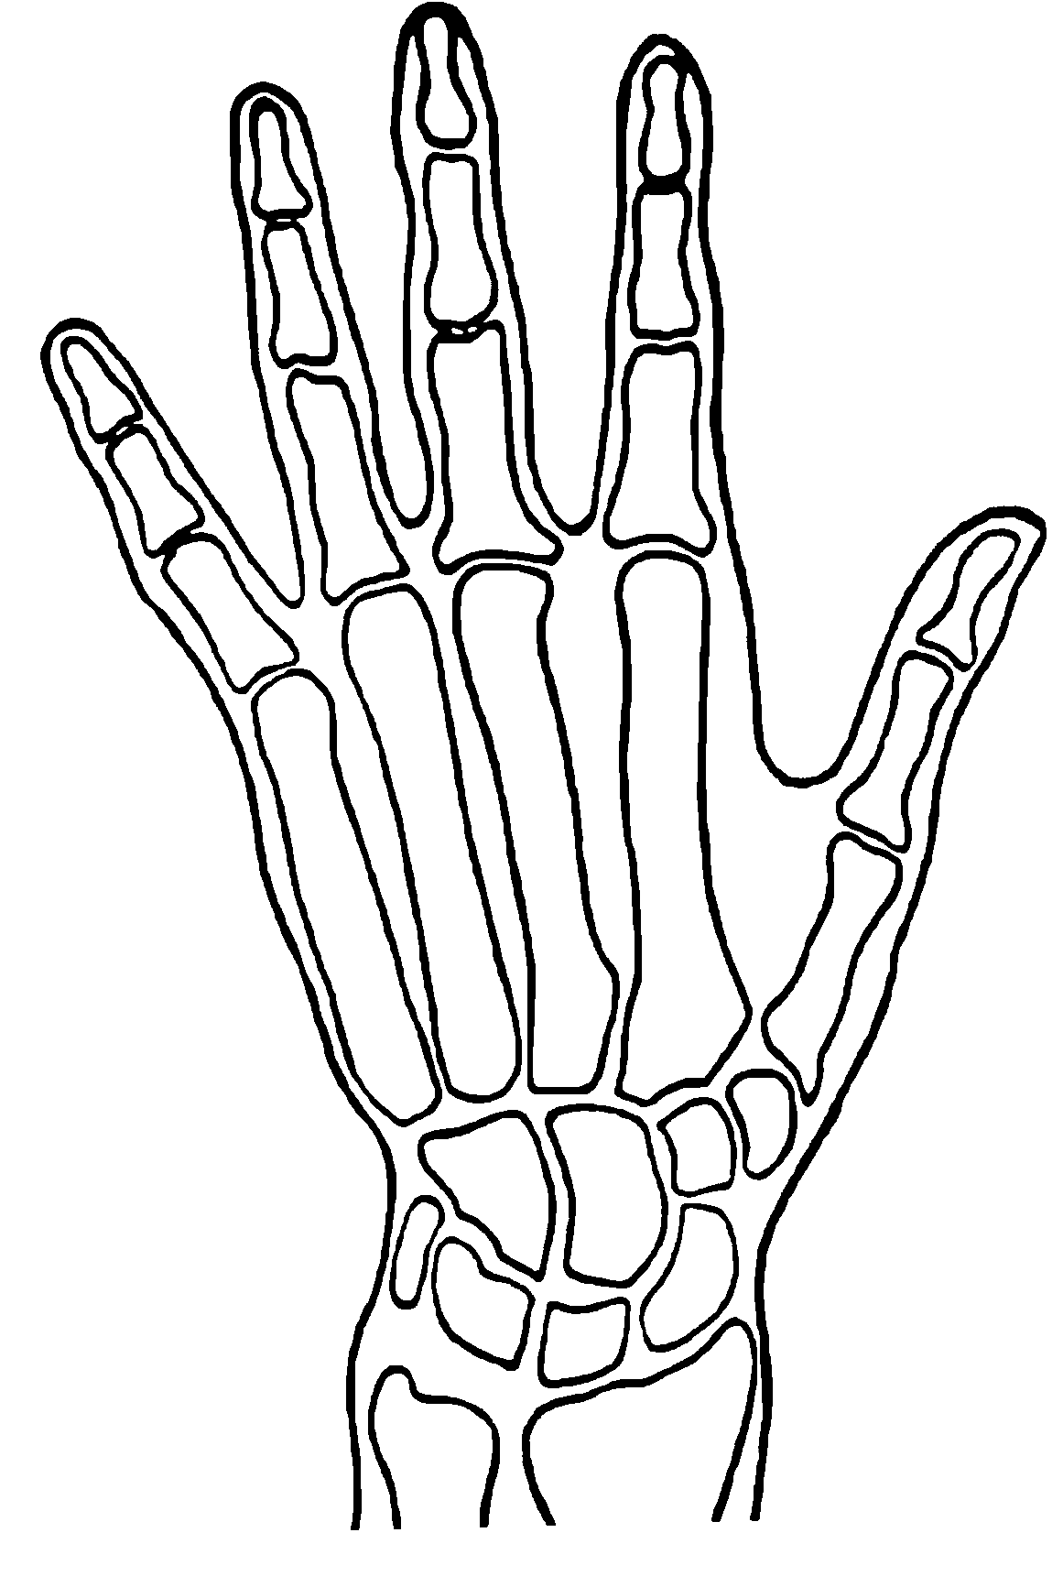
Distal Joint
Little Finger
Thumb
Proximal
Joint

If fingertip amputation is present, submit comparative x-rays or a statement indicating whether the bone loss was less than one-third, between one-third and two-thirds, or more than two-thirds of the distal phalanx.
Middle Joint

If amputation is below the distal joint, submit comparative x-rays.

