Letter Template Directions
- Open letter template in Microsoft Word.  - Enable viewing of hidden formatting symbols and text by clicking on "Show/Hide ¶" on the Paragraph tab:  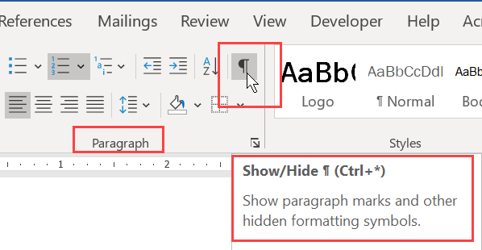  - Enter text in fields as prompted. Directions/prompts are formatted as hidden text, and are shown in blue.  - Save the completed letter to your file location with "<Insert Placement Partner/Company Name> Placement Partner Hiring Commitment" as the filename.  - Print the completed letter on Placement Partner/Company letterhead to PDF or hard copy. If printed to hard copy, scan and save to PDF format. Do not print hidden text. See directions for doing so at right.  - Upload document, at time of signing, dating and submitting application. |  | NOTE: Do not print hidden text. To do this, follow these steps in Microsoft Word:  - With the completed, saved letter open, select Options from the File menu. Word displays the Word Options dialog box.  - Select Display. (See Figure 1.)  - Under "Printing Options," make sure that the check box for "Print hidden text" is NOT selected. If the Print Hidden Text check box is selected, Word prints the hidden text.  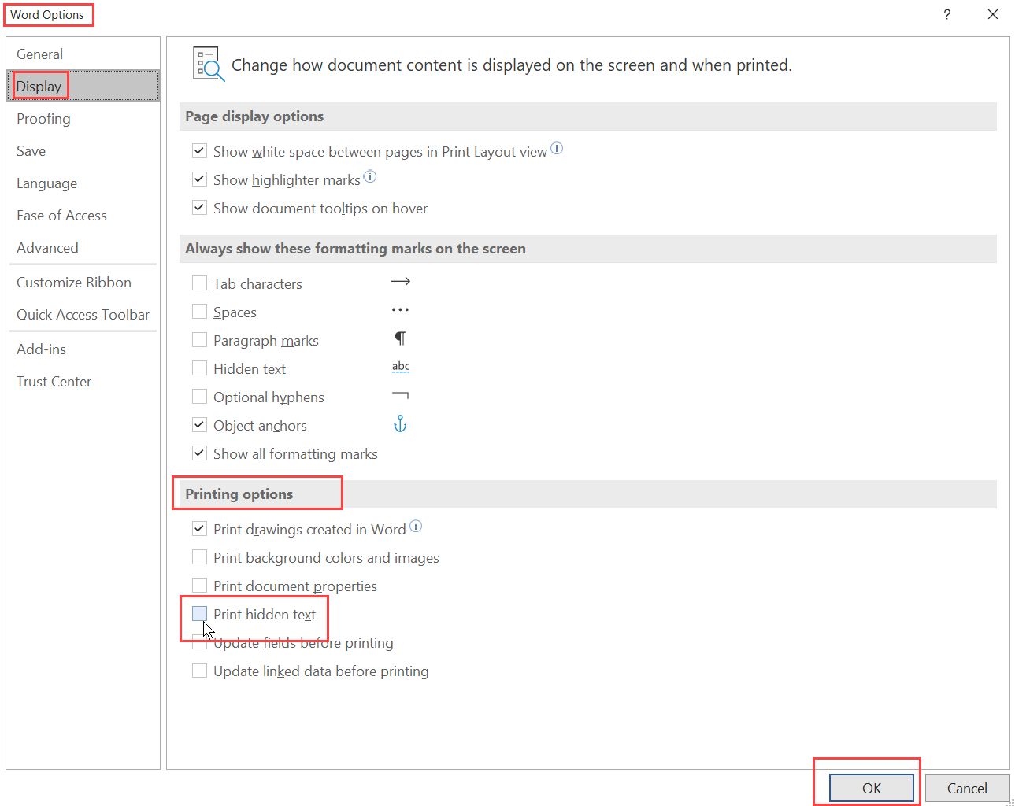  Figure 1. The Word Options dialog box.  - Click on OK.  - Save the document.  - Print the document to PDF or hard copy, on corporate stationery/letterhead.

Click or tap to enter a date.
Dear Evaluation Committee Members:
This letter confirms the participation of Insert Company Name as a Placement Partner for trainees in the Workforce Equity Grant occupational training program, Insert Program Name [implemented by Insert Implementor Name].
As a Placement Partner, Insert Company Name commits:
☒ To train and to place previously underemployed/unemployed workers in jobs.
☐ To train and to provide currently employed workers with a pay increase.
The specific project commitment(s) is stated in detail, as follows.
Trainee Placement Commitment details:
☐ Insert Company Name agrees to hire and to train Insert count underemployed workers who successfully complete training at an average wage of $Insert $XX.XX per hour, plus benefits.
☐ Insert Company Name agrees to train Insert count currently employed workers with a current average wage of $Insert $XX.XX per hour, plus benefits. Upon successful completion of the training, these workers will receive a wage increase of $Insert increase $XX.XX per hour.
☐ Insert Company Name agrees to hire and to train Insert count unemployed workers at an average wage of $Insert $XX.XX per hour, plus benefits.
Insert Company Name does not anticipate any circumstances, financial or legal, barring the company from meeting its commitments as presented in the Workforce Equity Grant application and this letter.
Sincerely,
Insert signature Click or tap to enter a date.
Authorized Signatory Name Date
Insert Title
Authorized Signatory Title
Insert Company Name
Placement Company Name

